Session 7 -1
class Solution {
public int removeElement(int[] nums, int val) {

int k = 0;

for (int i = 0; i < nums.length; i++) {

if (nums[i] != val) {

nums[k] = nums[i];
k++;
}
}
return k;
}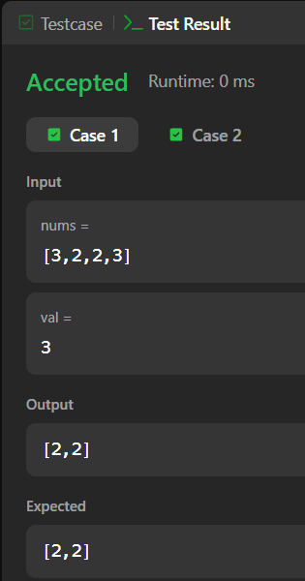

Session 7 - 2
class Solution {
public int removeDuplicates(int[] nums) {
if (nums.length == 0) {
return 0;
}
int k = 0;

for (int i = 1; i < nums.length; i++) {
if (nums[i] != nums[k]) {
k++;
nums[k] = nums[i];
}
}
return k + 1;
}
}
